**Our Classic Subs**

Classic subs come with tomatoes, pickles, onions, oil, oregano, salt & pepper.

*Mayonnaise & mustard upon request.*

***Small subs are around 6 inches long & large subs are around 11 inches long.***

**Ham**---------------------------------------------------------- **Sm. $5.75 Lg. $7.00**

**Ham & Cheese**---------------------------------------------- **Sm. $6.00 Lg. $7.50**

**Turkey** (Add cheese for $1.00) -------------------------------- **Sm. $5.75 Lg. $7.00**

**Ham & Turkey**---------------------------------------------- **Sm. $6.00 Lg. $7.50**

**American** (Turkey, Ham & Cheddar) -------------------------- **Sm. $6.00 Lg. $7.50**

**Four Cheese** (Provolone, Swiss, Cheddar & Pepperjack)-------- **Sm. $6.00 Lg. $7.50**

**Roast Beef** (Add cheese for $1.00)---------------------------- **Sm. $6.00 Lg. $7.50**

**Salami & Cheese**------------------------------------------- **Sm. $6.00 Lg. $7.50**

**Italian** (Provolone, Mortadella, Capicola & Salami)-------------- **Sm. $6.00 Lg. $7.50**

**Albacore Tuna** (With a touch of mayo)(Add cheese for $1.00) **Sm. $6.00 Lg. $7.50**

**Grilled Chicken Breast** (Add cheese for $1.00)-------------**Sm. $6.00 Lg. $7.50**

**Monday**

**Thru**

**Saturday**

**10 am to 4 pm**



541-269-9000

www.citysubs1

.com



***Our “secret”. We parbake our own sub rolls daily, from scratch, with no preservatives, and finish the baking when we make your sandwich.***



**Home of Annie the Chicken**

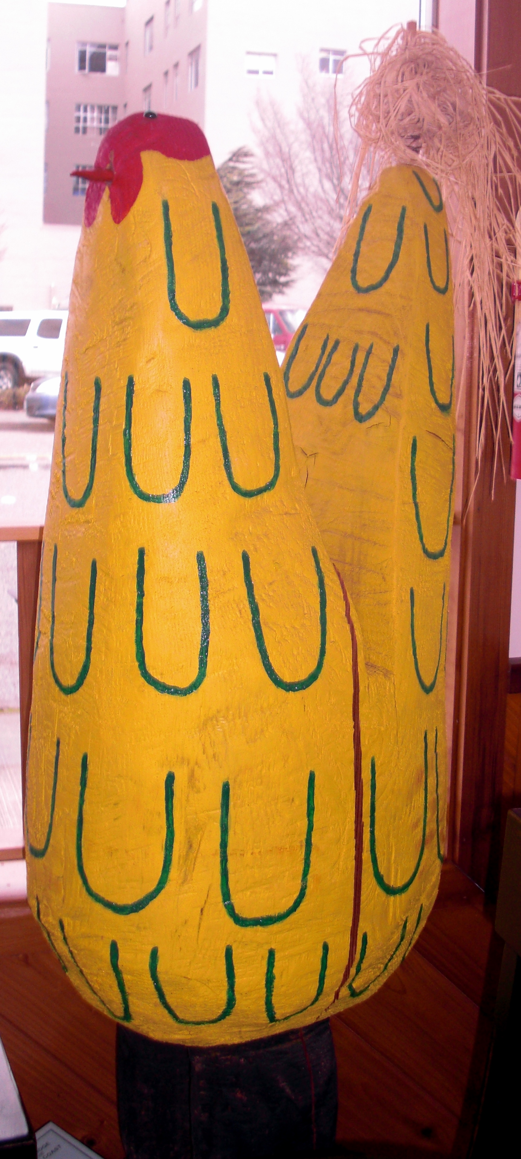

**Add to any sandwich, wrap, or salad:**

Cheese, Artichokes, Sprouts, Olives, Avocado or Extra Meat------$1.00

Add Bacon $1.00 per slice

**Cheeses**: Cheddar, Pepperjack, Provolone, Swiss, Parmesan, Feta & Cream Cheese.

**Our Specialty Subs**

Specialty subs have the ingredients listed below

**Gourmet Veggie**------------------------------------------ **Sm. $6.00 Lg. $7.50**

* Choice of cheese, plus lettuce, sprouts, avocado, artichoke hearts, tomatoes, onions, red bell peppers, oil & seasonings (Mustard & mayo upon request).

**California Club**---------------------------------------------- **Sm. $6.00 Lg. $7.50**

* Turkey, ham, bacon, tomato, avocado, mayonnaise, salt & pepper.
* (*Sprouts upon request*)

**Turkey with an Attitude**--------------------------------- **Sm. $6.00 Lg. $7.50**

* Turkey, bacon, cream cheese-guacamole sauce, sprouts & avocado.

**The Scarlet Turkey**----------------------------------------- **Sm. $5.75 Lg. $7.00**

* Turkey, cream cheese, & whole-berry cranberry sauce.

**Our Hot Subs**

Hot subs have the ingredients listed below

**Meatball**----------------------------------------------------- **Sm. $6.00 Lg. $7.50**

* Provolone cheese and meatballs in our homemade marinara sauce.

**Pastrami Melt**---------------------------------------------- **Sm. $6.00 Lg. $7.50**

* Mayonnaise, mustard, Pastrami, pickles, onions, topped with Swiss & melted.

**The Armadillo**----------------------------------------------- **Sm. $6.00 Lg. $7.50**

* Roast beef in our homemade barbeque sauce with tomatoes, jalapenos &

bacon topped with cheddar & melted.

**Salads**

**High Protein Salad**-------------------------------------------------------------------------------------**$8.75**

* A salad with tomato, onion, avocado, ½ a hardboiled egg, two slices of bacon and choice of one meat, one cheese, and one dressing.
  + **Meats**:Turkey, ham, salami, roast beef, meatballs in sauce, tuna, chicken, or pastrami.
  + **Cheeses**: Provolone, Pepperjack, Swiss, cheddar, Feta, parmesan, or cream cheese.
  + **Dressings**: Ranch, Italian, blue cheese, honey mustard, 1000 island, or balsamic Vinaigrette. Dressing comes onside. Extra dressing **.25 a cup.**

**Veggie Salad**---------------------------------------------------------------------------------------------**$8.75**

* A salad with your choice of one cheese & dressing. Plus, sprouts, avocado, artichoke hearts, tomatoes, onions, red bell peppers & ½ a hard-boiled egg. Add meat for **$1.00.** 
  + **Cheeses**: Provolone, Pepperjack, Swiss, cheddar, Feta, parmesan, or cream cheese.

**Dinner Salad**---------------------------------------------------------------------------------------------**$4.75**

* Lettuce, tomato, onion, red bell pepper, avocado, bacon & dressing. Add meat for **$1.00.**

**Wraps**

**Our wraps are made with low-carb tortillas that have only 6 grams of net carbs.**

***We also offer a gluten-free wrap for .50 extra, upon request***

**Annie Wrap**----------------------------------------------------------------------------------------------**$5.75**

* Chicken, bacon, red bell pepper, Pepperjack, avocado, lettuce & ranch.

**Meat-Lover’s Wrap**------------------------------------------------------------------------------------**$5.75**

* Pastrami, salami, Swiss cheese, lettuce, mustard & mayonnaise.

**Attitude Wrap**------------------------------------------------------------------------------------------**$5.75**

* Turkey, bacon, avocado, provolone, cream cheese-guacamole sauce, tomato & sprouts

**Veggie Wrap**--------------------------------------------------------------------------------------------**$5.75**

* Choice of cheese, plus lettuce, sprouts, avocado, artichoke hearts, tomatoes, onions & red bell peppers (*mustard and mayonnaise on request*).

**Cheese choices**: Cheddar, Pepperjack, provolone, Swiss, feta, parmesan & cream cheese.

**Children’s Subs**

**Grilled Cheese or a Peanut Butter and Jelly-**Small $4.00 or Large $6.00

**Other Sides**

We also have the following sides

**Soups-**We make soup daily. Sm. $3.95. Md. $4.95. Lg. $5.95.

**Salads**-We make our own Potato, Pasta and Macaroni salad weekly, supplies limited-$3.00 each

**Bread-**You can get a heated roll, a buttered toasted roll, or garlic toast.

**Chips-**Assorted Potato & Kettle Chips

**Desserts**-Assorted cookies & Macaroons (Baked fresh daily) & Nanaimo Bars-$1.50 each

**Drinks**-Coffee, assorted hot teas, apple juices, canned sodas, etc.