OUR MENU

**Our Classic Subs**

Comes with tomatoes, pickles, onions, oil, oregano, salt & pepper.

Mayonnaise & mustard upon request.

**Small Large**

**#1-Ham** ……………………………………………………………………………………… $5.55 $6.95

**#2-Turkey**…………………………………………………………………………………. $5.55 $6.95

**#3-Four Cheese** (Provolone, Swiss, Cheddar & Pepperjack) ………. $5.55 $6.95

**#4-Salami & Cheese of your choice\*\***………………………………………. $5.55 $6.95

**#5-Roast Beef**……………………………………………………………………………. $5.55 $6.95

**#6-Ham & Cheese of your choice**\*\*…………………………………………… $5.55 $6.95

**#7-Ham & Turkey**………………………………………………………………………. $5.55 $6.95

**#8-American \*\***(Ham, Turkey & Cheddar) ………………………………… $5.75 $7.15

**#9-Italian \*\***(Provolone, Mortadella, Capicola & Salami) …………… $5.75 $7.15

**#10-Albacore Tuna** (with a touch of mayo) …………………………………$5.55 $6.95

**#14-Chicken Breast**……………………………………………………………………. .$5.55 $6.95

**\*\*Comes w/cheese\*\***

**Cheese choices**: Cheddar, Pepperjack, Provolone, Swiss, Parmesan, Feta & Cream Cheese.

**

**Open Monday thru Friday**

**8 am to 7 pm**

**Saturday**

**10 am to 4 pm**

**Sunday**

**Closed**



149 N. 4th Street

Coos Bay, Oregon 97420

541-269-9000

https://www.citysubs1.com/



*Catering Available*

*Monthly Specialty Sub*



**Home of Annie the Chicken**

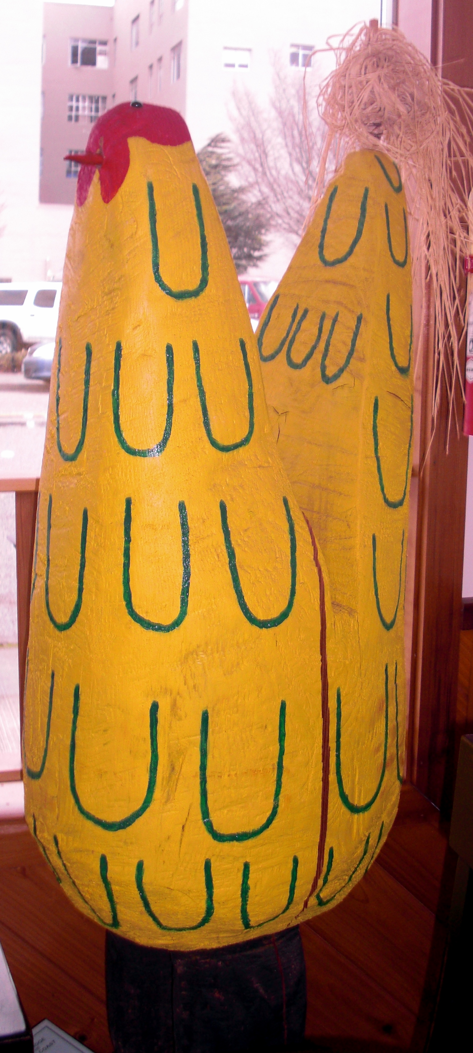

**Specialty Subs**

**Small Large**

**#15-Gourmet Veggie**…………………………………………………………………. $ 5.95 $7.25

Choice of cheese, plus lettuce, sprouts, avocado, artichoke hearts, tomatoes, onions, red bell peppers, oil & seasonings (Mustard & mayo upon request).

**#16-Ham, Egg & Cheese**…………………………………………………………. $5.65 $6.95

Butter, cheddar cheese (or other cheese of choice), scrambled eggs, ham,

salt & pepper.

**#17-Bacon, Egg & Cheese**…………………………………………………………. $5.65 $6.95

Butter, cheddar cheese (or other cheese of choice), scrambled eggs, bacon,

salt & pepper.

**#18-California Club**……………………………………………………………………. $5.95 $7.25

Turkey, ham, bacon, tomato, avocado, mayonnaise, salt & pepper.

(*Sprouts upon request*)

**#19-Turkey with an Attitude**……………………………………………………… $5.95 $7.25

Turkey, bacon, cream cheese-guacamole sauce, sprouts & avocado.

**#20-The Scarlet Turkey**………………………………………………………………. $5.95 $7.25

Turkey, cream cheese, & whole-berry cranberry sauce.

**#50-Sandwich of the Month** Prices Vary

(Ask about our latest specials)

**#54-Previous** **Sandwich of the Month** Prices Vary

(Ask to see this menu. Subject to ingredient availability)

**Hot Subs**

**Small Large**

**#11-Meatball**…………………………………………………………………………….. $5.95 $7.25

Provolone cheese and meatballs in our homemade marinara sauce.

**#12-Pastrami Melt**………………………………………………………… …………. $5.95 $7.25

Mayonnaise, mustard, Pastrami, pickles, onions, topped with Swiss & melted.

**#13-The Armadillo**…………………………………………………………………….. $5.95 $7.25

Roast beef in our homemade barbeque sauce with tomatoes, jalapenos & bacon topped with cheddar & melted.

Also ask about our “Previous Sandwiches of the Month” that are hot.

**Wraps**

**Our wraps are made with low-carb wheat tortillas that have only five grams of fat.**

***We also offer a gluten-free wrap for .25 extra, upon request***

**#90-Annie Wrap**…………………………………………………………………………………………………$5.50

Chicken, bacon, red bell pepper, Pepperjack, avocado, lettuce & ranch.

**#91-Meat-Lover’s Wrap**……………………………………………………………………..................$5.50

Pastrami, salami, Swiss cheese, lettuce, mustard & mayonnaise.

**#92 -Attitude Wrap**……………………………………………………………………………………………$5.50

Turkey, bacon, avocado, provolone, cream cheese-guacamole sauce, tomato

& sprouts

**#93- Veggie Wrap**………………………………………………………………………………………………$5.50

Choice of cheese, plus lettuce, sprouts, avocado, artichoke hearts, tomatoes, onions & red bell peppers (*mustard and mayonnaise on request*).

**Cheese choices**: Cheddar, Pepperjack, provolone, Swiss, feta, parmesan

& cream cheese.

**Salads**

**Our Salad**………………………………………………………………………………………………………….$8.00

A salad with tomato, onion, avocado, ½ a hardboiled egg & two slices of bacon.

*Also comes with your choice of one meat, one cheese & one dressing.*

**Meats**:Turkey, ham, salami, roast beef, albacore tuna, chicken, pastrami

or meatballs in marinara sauce.

**Cheeses**: Provolone, Pepperjack, Swiss, cheddar, Feta, parmesan

or cream cheese.

**Dressings**: Ranch, Italian, blue cheese, honey mustard, 1000 island or

fat-free red raspberry vinaigrette.

**Veggie Salad**………………………………………………………………………………………………………$8.00

A salad with your choice of cheese & dressing. Plus, sprouts, avocado,

artichoke hearts, tomatoes, onions, red bell peppers & ½ a hard-boiled egg.

**Dressings**: Ranch, Italian, blue cheese, honey mustard, 1000 island or

fat-free red raspberry vinaigrette.

**Dinner Salad**………………………………………………………………………………………………………$4.50

Lettuce, tomato, onion, red bell pepper, avocado, bacon & dressing.

**Dressings**: Ranch, Italian, blue cheese, honey mustard, 1000 island or

fat-free red raspberry vinaigrette.

**Potato Salad-6oz**.…………………………………………………………………………………………......$1.75

**Macaroni Salad-5oz**.…………………………………………………………………………………….......$1.75

***Our “secret”. We parbake our own sub rolls daily, from scratch, with no preservatives, and finish the baking when we make your sandwich.***

***We offer small subs which are around 6 inches long & large subs which are around 11 inches long.***

***We DO NOT sell half subs.***

**Hot & Cold Drinks**

**Pepsi Product Fountain Drinks**………………………………...16 oz. $1.70 22 oz. $1.90

**Coffee**…………………………………………………………………………………$1.50

**Assorted Hot Teas**………………………………………………………………$1.50

**Hot Chocolate**…………………………………………………………………….$1.50

**Assorted Pepsi Product Bottled Soda**…………………………………$2.25

**Assorted Canned Sodas**………………………………………………………$1.75

**Freshly Brewed, Unsweetened Iced Tea**…………………………… $1.70

**Assorted Fruit Juices**…………………………………………………………..$2.25

**Assorted Romano’s Italian Sodas**……………………………………...$2.25

**Thomas Kemper Root Beer or Ginger Ale………**………………… $2.25

**Martinelli’s Sparkling Apple Juice Cider**…………………………….$1.75

**Bottled Water**…………………………………………………………………….$1.00

**Red Bull**……………………………………………………………………………...$2.75

**Carton of Umpqua 2% Milk or Dutch Chocolate Milk…**……..$1.75

**V8**……………………………………………………………………………………….$1.75

**Extras**

**Small Large**

**Cheese or Avocado**…...75₵ 90₵

**Meat**………………………….85₵ $1.00

**Bacon**…………………………85₵ $1.25

**Sprouts or Artichokes**. 25₵ 50₵

**Side of Dressing** 25₵ per cup

**Special orders** 50₵ extra

**Children’s Subs**

(On our small sub roll)

**Toasted Cheese**……………………$3.75

**PB & J**…………………………………..$3.75

**Our Soups**

4 soups daily (Mon – Fri)

2 soups daily (Sat)

**Small-8 oz.** …………………………..$3.50

**Medium-12 oz.** ……………………$4.75

**Large-16 oz.** …………………………$5.50

**Bread**

**Heated Roll w/Butter**…………..$1.75

**Toasted Butter Roll**………………$2.00

**Garlic Bread**…………………………$2.00

**Cinnamon Toast**…………………..$2.25

**Dinner Rolls**…….**$3.50 for ½ dozen**

They are special order items so they need to be ordered 24 hours in advance

**Potato Chips**

**Assorted Lay’s Chips**…………….$1.00

**Assorted Kettle Chips**…………..$1.40

**Desserts**

**Nanaimo Bars**………………………$1.50

**Coconut Macaroons**…………….$1.50

**Lemonburst Macaroons**………$1.50

**Assorted Cookies**…………………$1.50

(Baked fresh daily)

**Hand Dipped Ice Creams**

(Assortment of Umpqua Ice Cream)

**Catering**

Ask about our catering prices.