**Our Classic Subs**

Classic subs come with tomatoes, pickles, onions, oil, oregano, salt & pepper.

*Mayonnaise & mustard upon request.*

***We offer small subs which are around 6 inches long & large subs which are around 11 inches long.***

**#1-Ham**------------------------------------------------------ **Sm. $5.55 Lg. $6.95**

**#2-Turkey**--------------------------------------------------- **Sm. $5.55 Lg. $6.95**

**#3-Four Cheese** (Provolone, Swiss, Cheddar & Pepperjack)- **Sm. $5.85 Lg. $7.15**

**#4-Salami & Cheese**-------------------------------------- **Sm. $5.85 Lg. $7.15**

**#5-Roast Beef**---------------------------------------------- **Sm. $5.85 Lg. $7.15**

**#6-Ham & Cheese**----------------------------------------- **Sm. $5.85 Lg. $7.15**

**#7-Ham & Turkey**----------------------------------------- **Sm. $5.85 Lg. $7.15**

**#8-American** (Turkey, Ham & Cheddar)--------------------- **Sm. $5.85 Lg. $7.15**

**#9-Italian** (Provolone, Mortadella, Capicola & Salami)-------- **Sm. $5.85 Lg. $7.15**

**#10-Albacore Tuna** (With a touch of mayo)--------------- **Sm. $5.95 Lg. $7.25**

**#14-Grilled Chicken Breast**----------------------------- **Sm. $5.85 Lg. $7.15**

**Cheese choices**: Cheddar, Pepperjack, Provolone, Swiss, Parmesan, Feta & Cream Cheese.

**Monday**

**Thru**

**Saturday**

**10 am to 4 pm**



541-269-9000

www.citysubs1

.com



***Our “secret”. We parbake our own sub rolls daily, from scratch, with no preservatives, and finish the baking when we make your sandwich.***



**Home of Annie the Chicken**

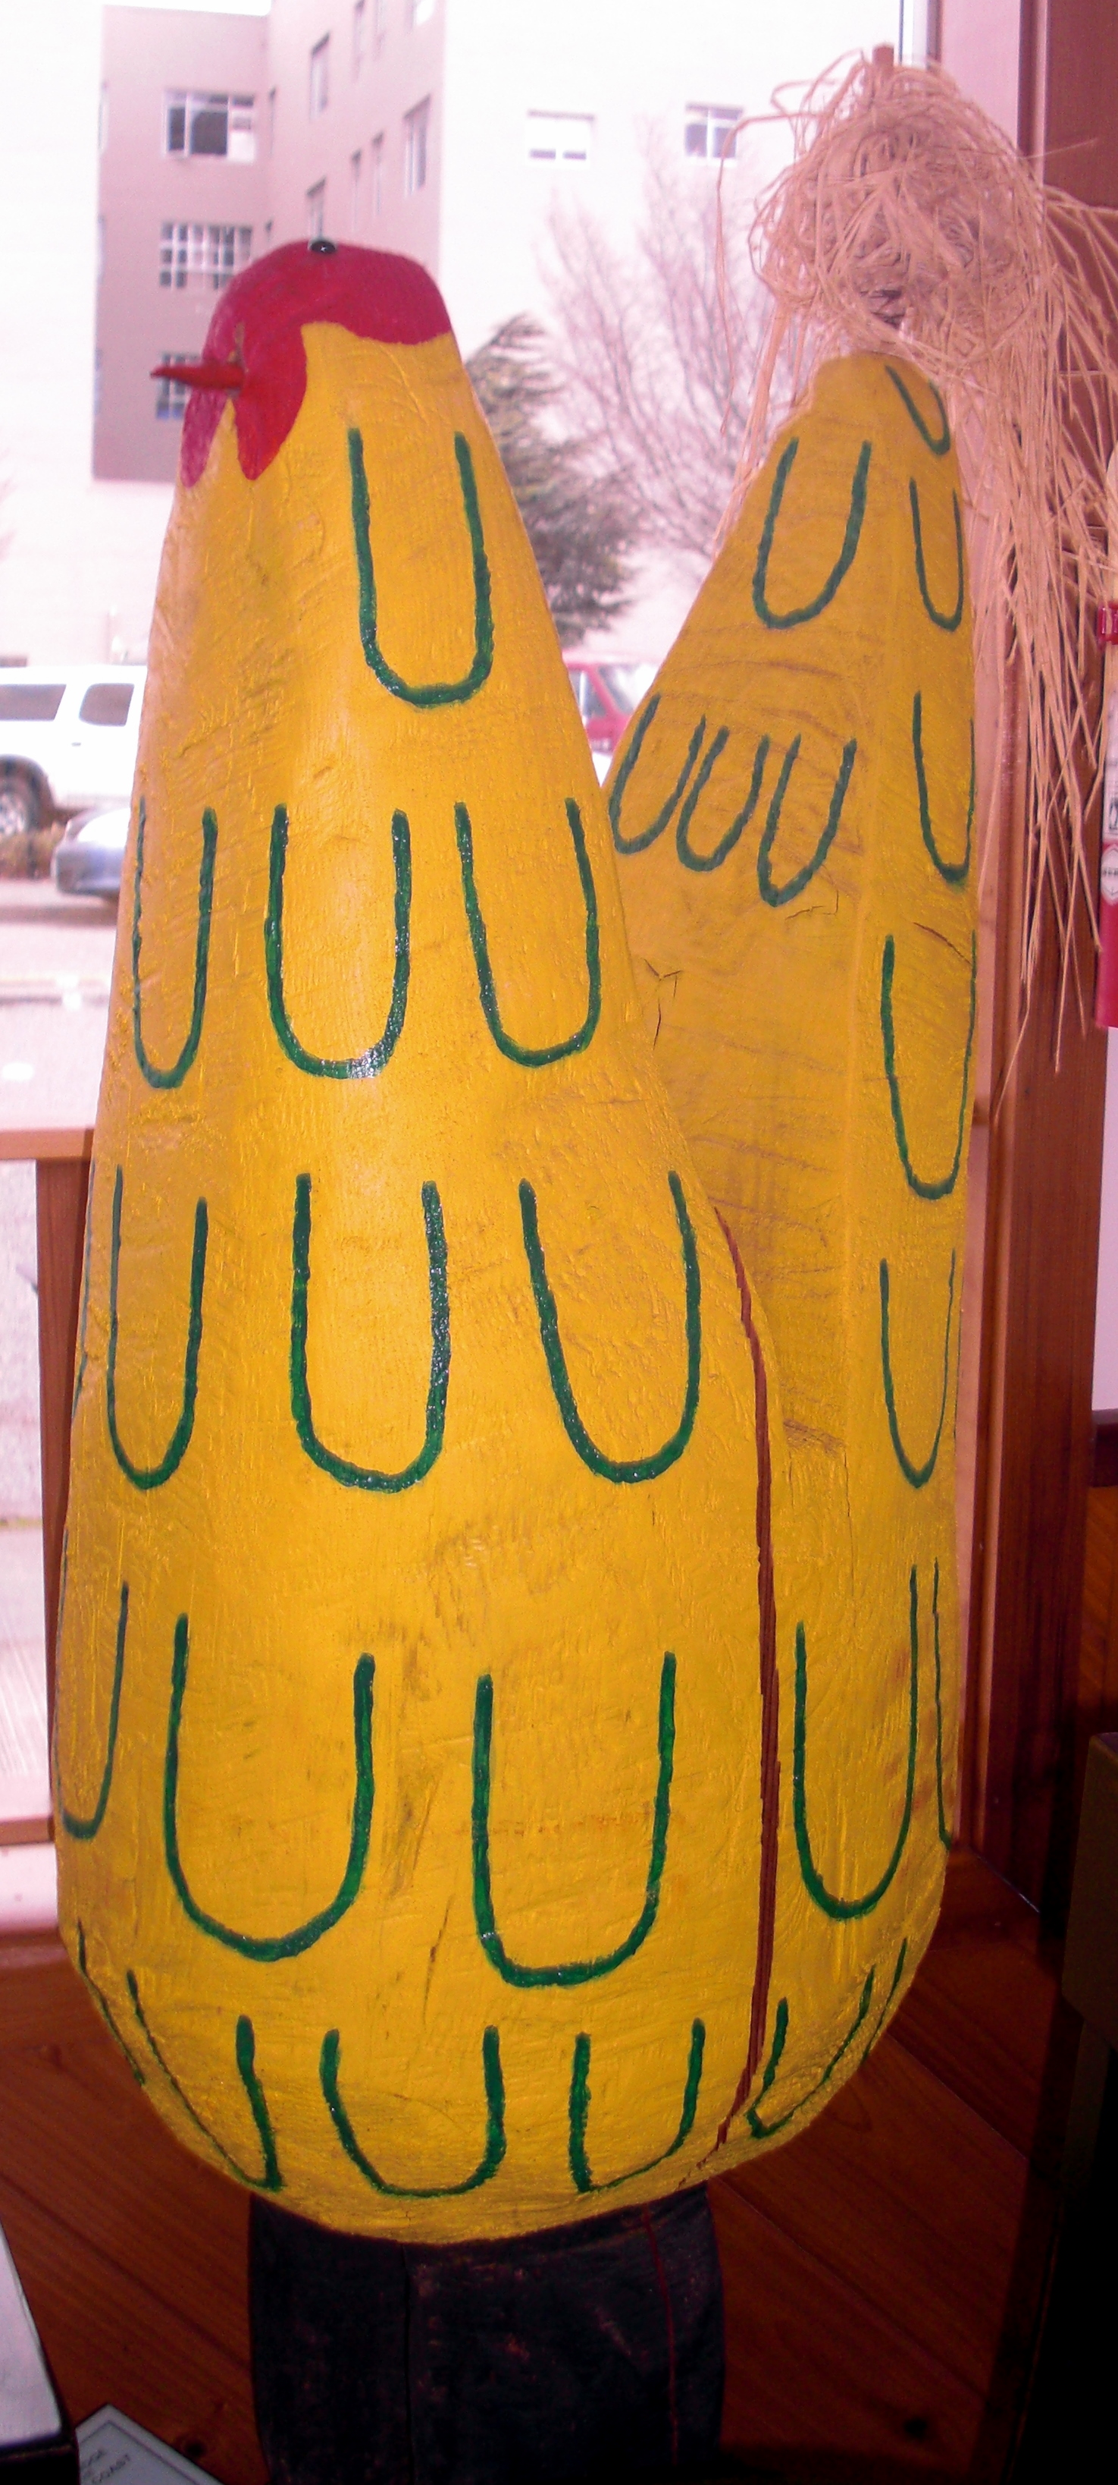

**Our Hot Subs**

Hot subs have the ingredients listed below

**#11-Meatball**---------------------------------------------- **Sm. $5.95 Lg. $7.25**

* Provolone cheese and meatballs in our homemade marinara sauce.

**#12-Pastrami Melt**--------------------------------------- **Sm. $5.95 Lg. $7.25**

* Mayonnaise, mustard, Pastrami, pickles, onions, topped with Swiss & melted.

**#13-The Armadillo**--------------------------------------- **Sm. $5.95 Lg. $7.25**

* Roast beef in our homemade barbeque sauce with tomatoes, jalapenos &

bacon topped with cheddar & melted.

**Our Specialty Subs**

Specialty subs have the ingredients listed below

**#15-Gourmet Veggie**------------------------------------ **Sm. $5.95 Lg. $7.25**

* Choice of cheese, plus lettuce, sprouts, avocado, artichoke hearts, tomatoes, onions, red bell peppers, oil & seasonings (Mustard & mayo upon request).

**#18-California Club**--------------------------------------- **Sm. $5.95 Lg. $7.25**

* Turkey, ham, bacon, tomato, avocado, mayonnaise, salt & pepper.
* (*Sprouts upon request*)

**#19-Turkey with an Attitude**--------------------------- **Sm. $5.95 Lg. $7.25**

* Turkey, bacon, cream cheese-guacamole sauce, sprouts & avocado.

**#20-The Scarlet Turkey**----------------------------------- **Sm. $5.95 Lg. $7.25**

* Turkey, cream cheese, & whole-berry cranberry sauce.

**Add Cheese, Artichokes or Avocado**------**Small 75₵ Large 90₵**

**Add Sprouts or Meat**-----**Small** **85₵ Large $1.25 Add Bacon $1.00 per slice**

**Salads**

**High Protein**---------------------------------------------------------------------------------------------**$8.50**

* A salad with tomato, onion, avocado, ½ a hardboiled egg & two slices of bacon.
* *Also comes with your choice of one meat, one cheese & one dressing.*
  + **Meats**:Turkey, ham, salami, roast beef, albacore tuna, chicken or pastrami.
  + **Cheeses**: Provolone, Pepperjack, Swiss, cheddar, Feta, parmesan or cream cheese.
  + **Dressings**: Ranch, Italian, blue cheese, honey mustard, 1000 island or fat-free red raspberry vinaigrette. Extra dressing **.25 a cup.**
* Add a side of Croutons made from our bread. **.25 a cup.**

**Veggie Salad**---------------------------------------------------------------------------------------------**$8.50**

* A salad with your choice of cheese & dressing. Plus, sprouts, avocado, artichoke hearts, tomatoes, onions, red bell peppers & ½ a hard-boiled egg.

**Dinner Salad**---------------------------------------------------------------------------------------------**$4.50**

* Lettuce, tomato, onion, red bell pepper, avocado, bacon & dressing.

**Wraps**

**Our wraps are made with low-carb tortillas that have only 6 grams of net carbs.**

***We also offer a gluten-free wrap for .50 extra, upon request***

**#90-Annie Wrap**----------------------------------------------------------------------------------------**$5.50**

* Chicken, bacon, red bell pepper, Pepperjack, avocado, lettuce & ranch.

**#91-Meat-Lover’s Wrap**------------------------------------------------------------------------------**$5.50**

* Pastrami, salami, Swiss cheese, lettuce, mustard & mayonnaise.

**#92 -Attitude Wrap**----------------------------------------------------------------------------------- **$5.50**

* Turkey, bacon, avocado, provolone, cream cheese-guacamole sauce, tomato & sprouts

**#93- Veggie Wrap**--------------------------------------------------------------------------------------**$5.50**

* Choice of cheese, plus lettuce, sprouts, avocado, artichoke hearts, tomatoes, onions & red bell peppers (*mustard and mayonnaise on request*).

**Cheese choices**: Cheddar, Pepperjack, provolone, Swiss, feta, parmesan & cream cheese.

**Children’s Subs**

**Toasted Cheese or a PB & J** (Both come on one of our small sub rolls)------------------$3.75

**Other Sides**

We also have the following sides

**Soups-**We make 1 to 4 soups daily

**Salads**-We make our own Potato and Macaroni salad weekly, supplies limited

**Bread-**You can get a heated roll, a buttered toasted roll or garlic toast.

**Chips-**Assorted Lay’s, Tim’s, Miss Vickie’s & Kettle Brand Potato Chips

**Desserts**-Assorted cookies & Macaroons (Baked fresh daily) & Naniamo Bars

**Drinks**-Coffee, assorted hot teas, apple juices, canned sodas, etc.